

|  |  |  |  |  |  |  |  |  |
| --- | --- | --- | --- | --- | --- | --- | --- | --- |
|  | | | | | | | | |
|  | | Assignment . 2 | | | | |  | |
|  |  | | | | | | |  |
|  | | | |  |  | | | |
|  | | | | MujtabaSP22-BSE-036 |  | | | |
|  | | | | Nov 11, 2022—Programming Fundamentals—Sir Rizwan Rashid |  | | | |
|  | | |  | | |  | | |

Notes

I only pasted **main** part of the code here. This part is same for each question, so it is omitted for code readability:

public class Main {  
 public static void main(String [] args){  
 // -  
 }  
}

QUESTION . 1

// Question . 1  
// Starting from 0th digit, code must be  
// 10 digits with 2 dashes at index 3 and 6  
public static boolean validateSSN(String ssn){  
 for(int i = 0; i < ssn.length() - 1; i++){  
 if(i == 3 || i == 6) continue;  
 else {  
 if(Character.isDigit(ssn.charAt(i))) continue;  
 return false;  
 }  
 }  
 return ((ssn.length() - 1) == 10) &&  
 (ssn.charAt(3) == '-') &&  
 (ssn.charAt(6) == '-');  
}

OUTPUT

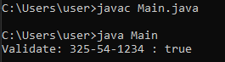

QUESTION . 2

// Question . 2  
// M,C,I Majors and 1,2,3,4 Status  
public static void majorsStatus(){  
 String major, status;  
 System.out.print("Enter 2 characters for your major-status: ");  
 String s = new Scanner(System.in).next();  
 char[] chars = {s.charAt(0), s.charAt(1)};  
 switch(chars[0]){  
 case 'M': major = "Mathematics"; break;  
 case 'C': major = "Computer"; break;  
 case 'I': major = "IT"; break;  
 default: major = "Undefined"; break;  
 }  
 switch(chars[1]){  
 case '1': status = "Freshman"; break;  
 case '2': status = "Sophomore"; break;  
 case '3': status = "Junior"; break;  
 case '4': status = "Senior"; break;  
 default: status = "Undefined"; break;  
 }  
 System.out.println(major + " " + status);  
}

OUTPUT

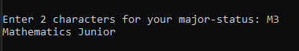

QUESTION . 3

// Question . 3  
// Generate car plate number in format: ABC 1234  
public static String generatePlateNo(){  
 String no = "";  
 for(int l = 0; l < 3; l++) no += (char)((int)'A' + Math.random() * (int)'Z');  
 no += " ";  
 for(int l = 0; l < 4; l++) no += (char)((int)'0' + Math.random() * (int)'9');  
 return no;  
}

OUTPUT



QUESTION . 4

// Question . 4  
// Decimal to Binary  
public static String dec2bin(int decimal){  
 String binaryNumber = "";  
 for(int quotient = decimal; quotient != 0; quotient /= 2)  
 binaryNumber += quotient % 2;  
 return binaryNumber;  
}

OUTPUT



QUESTION . 5

class Question5 {  
 static String[] questions = {  
  
 "Question 1. What is the greenhouse effect??\n"+  
 "Select Options:\n"+  
 "1. Certain gases in the atmosphere trap heat and warm the Earth\n"+ // CORRECT  
 "2. Life on Earth 'exhales' gas that warms up the atmosphere\n"+  
 "3. The tilt of the Earth changes the amount of solar energy the Earth receives\n"+  
 "4. The Sun is putting out more radiant energy over time\n\n"  
 ,  
  
 "Question 2. Which activities are the largest contributors of greenhouse gases??\n"+  
 "Select Options:\n"+  
 "1. Deforestation\n"+  
 "2. Transportation \n"+ // CORRECT  
 "3. Agriculture\n"+  
 "4. Industry\n\n"  
 ,  
  
 "Question 3. How has the global average temperature changed since the Industrial Revolution??\n"+  
 "Select Options:\n"+  
 "1. Cooler by 0.1 degree C (0.2 degree F)\n"+  
 "2. The temperature has gone up and down, but remains overall the same\n"+  
 "3. Warmer by 0.1 degree C (0.2 degree F)\n"+  
 "4. Warmer by more than 1 degree C (2.1 degrees F)\n\n" // correct  
 ,  
  
 "Question 4. How does the rate of today's warming compare to previous episodes of rapid climate change on Earth??\n"+  
 "Select Options:\n"+  
 "1. Today's climate warming is about as fast as the temperature swings that have happened in Earth's past.\n"+  
 "2. Past changes in the climate have been faster than the changes we're seeing today.\n"+  
 "3. Today, the Earth's climate is changing much faster than it has changed in the past.\n"+ // correct  
 "4. N/A\n\n"  
 ,  
  
 "Question 5. When was the last time in Earth's history that CO2 was as high as it is now??\n"+  
 "Select Options:\n"+  
 "1. This is the highest it's ever been\n"+  
 "2. CO2 was at least this high during the warm periods between the ice ages\n"+  
 "3. CO2 has not been this high for almost one million years.\n"+  
 "4. The last time CO2 was this high was 3 million years ago.\n\n" // CORRECT  
 ,  
 };  
  
 public static void takeQuiz(){  
 int score = 0;  
 // Print quiz  
 Scanner s = new Scanner(System.in);  
 System.out.println("Mujtaba Quiz Taker\nWelcome\n\nQuestions:\n\n");  
 for(int i = 0; i < 5; i++){  
 System.out.print(questions[i]);  
 int selectedOption = s.nextInt();  
 // Correct answers for questions (in order): 1,2,4,3,4  
 switch(i){  
 case 0: score += selectedOption == 1 ? 1 : 0; break;  
 case 1: score += selectedOption == 2 ? 1 : 0; break;  
 case 2: score += selectedOption == 4 ? 1 : 0; break;  
 case 3: score += selectedOption == 3 ? 1 : 0; break;  
 case 4: score += selectedOption == 4 ? 1 : 0; break;  
 default: {  
 System.out.println("\nInvalid Option!\nRe-taking this Question\n");  
 i--; break;  
 }  
 }  
 }  
 System.out.println("\nYour score: " + score + "\n");  
 }  
}

OUTPUT

[ON NEXT PAGE]

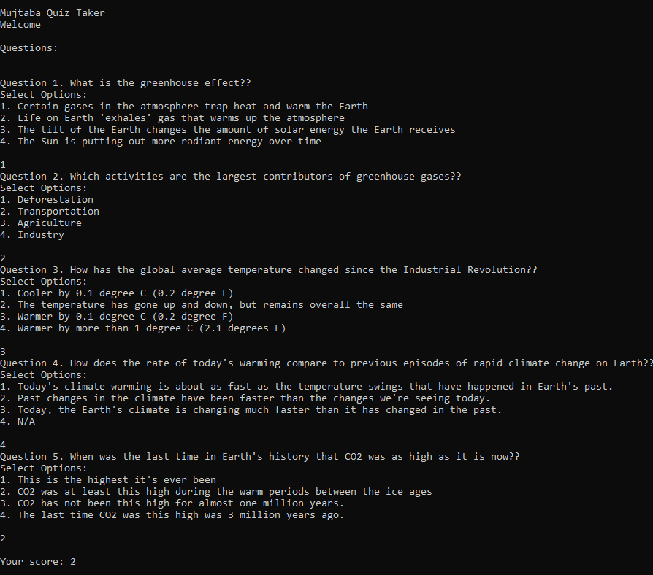

THANK YOU